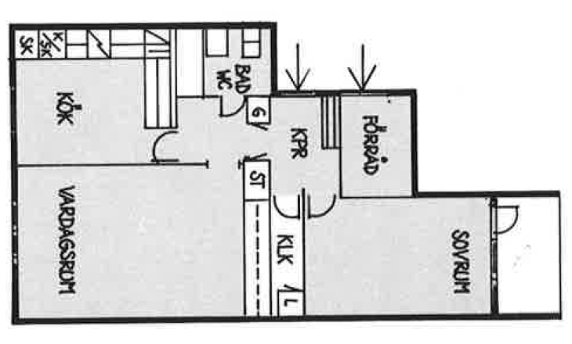

Vita Hasselbacken
2 r.o.k
61 kvm

